**University of Canterbury**

*DATA475 – Mixed Reality*

VR Assignment (Assignment 2)

**REPORT**

*Visualising Learning Management System Login Location Data*

***Names:*** Richard Davies – 32001660

Thong Minh Nguyen (Martin) – 68623131

***Lecturers:*** Professor Rob Lindemann

Postdoc Fellow Sungchul Jung

1. **Purpose of the project**

The purpose of this project was to find the best way to visualise global location data from UC’s Learning Management System (LEARN) using Virtual Reality (VR). This would make it possible to see how the recent lockdown affected where users were logging in from. An increase in access to LEARN from different countries around the world had been observed, and it was desirable to get a clear understanding of what was happening using some form of visualisation.

1. **Project outcomes**

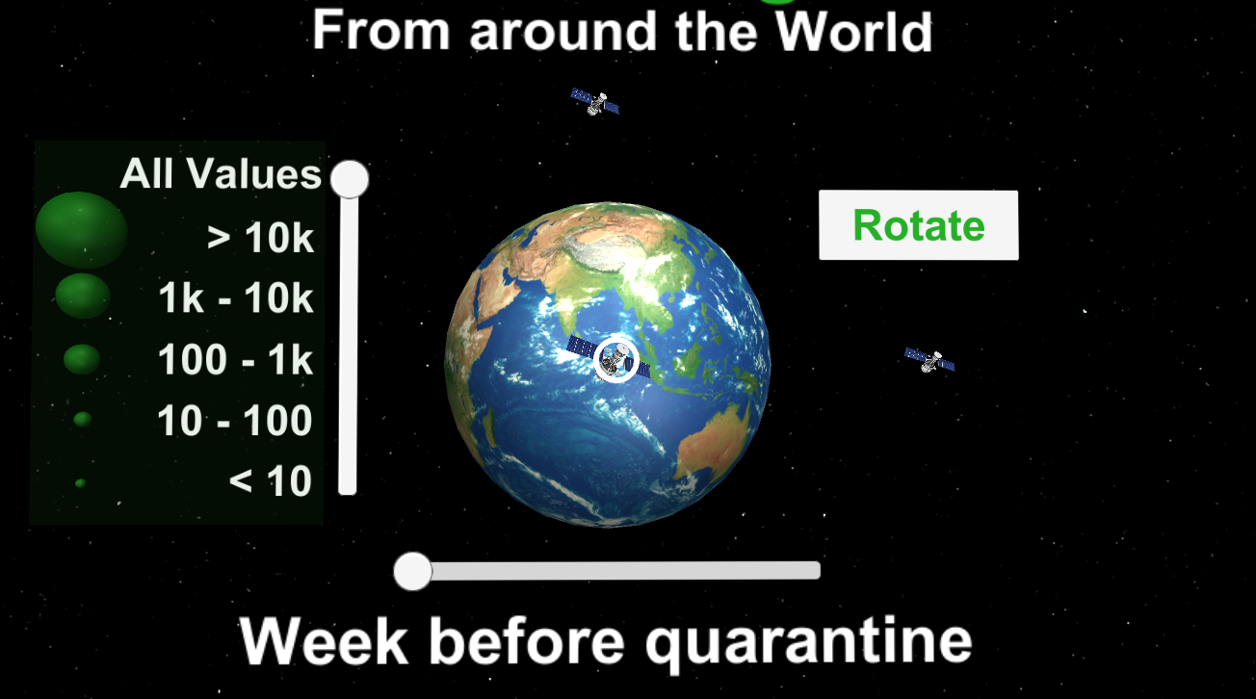

*Figure 1: General view of the project*

The outcome is a VR visualisation prototype, created using Unity, to be used with an Android phone and a Google Cardboard style device. It is designed so that given a file containing login data the user can view that data in VR by looking at a 3D globe. The user can manipulate the data by filtering by time and/or by grouped numbers of users using two sliders. Different viewpoints on the visualization can be achieved either by rotating the globe (clicking a Rotate button) or by transporting to different points around the globe (clicking on Satellites). The transportation allows the viewer to get a different perspective on how the lockdown affected the location of LEARN users.

1. **Rationale for VR**

This type of data is suitable for VR visualisation as it provides a way of presenting the data with immediate understanding of the trends, it allows for real time manipulation of the visualization, and gives insights not easily shown through 2D methods.

Firstly, using a globe to show where users have been logging in from, gives immediate understanding of geographical trends. The small green sphere’s, varying in size depending on the numbers, create a visual representation of what would have been previously numerical information.

Secondly, within this type of VR experience you can easily interact with the data. The controls allow you to easily filter to different days and/or sub-groups of the data. This real time manipulation can be a powerful experience for the user.

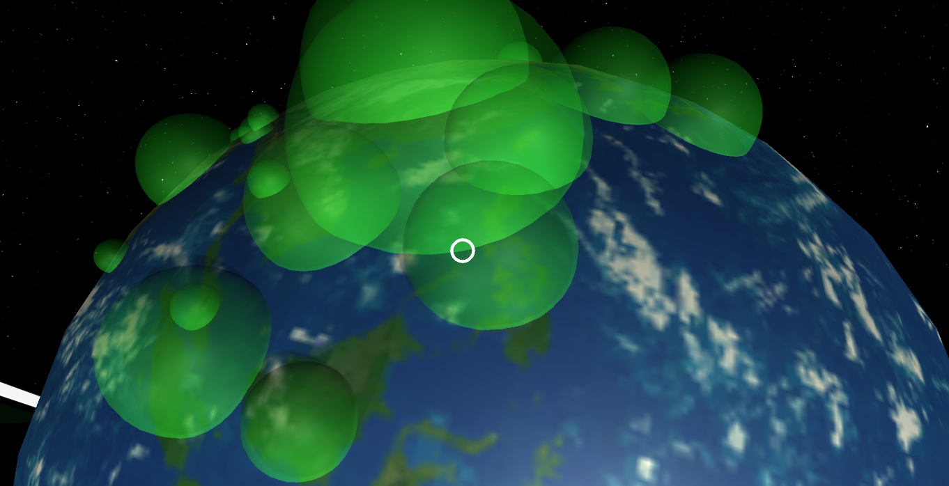

*Figure 2: Data closely viewed from the top of the globe (by clicking the satellites)*

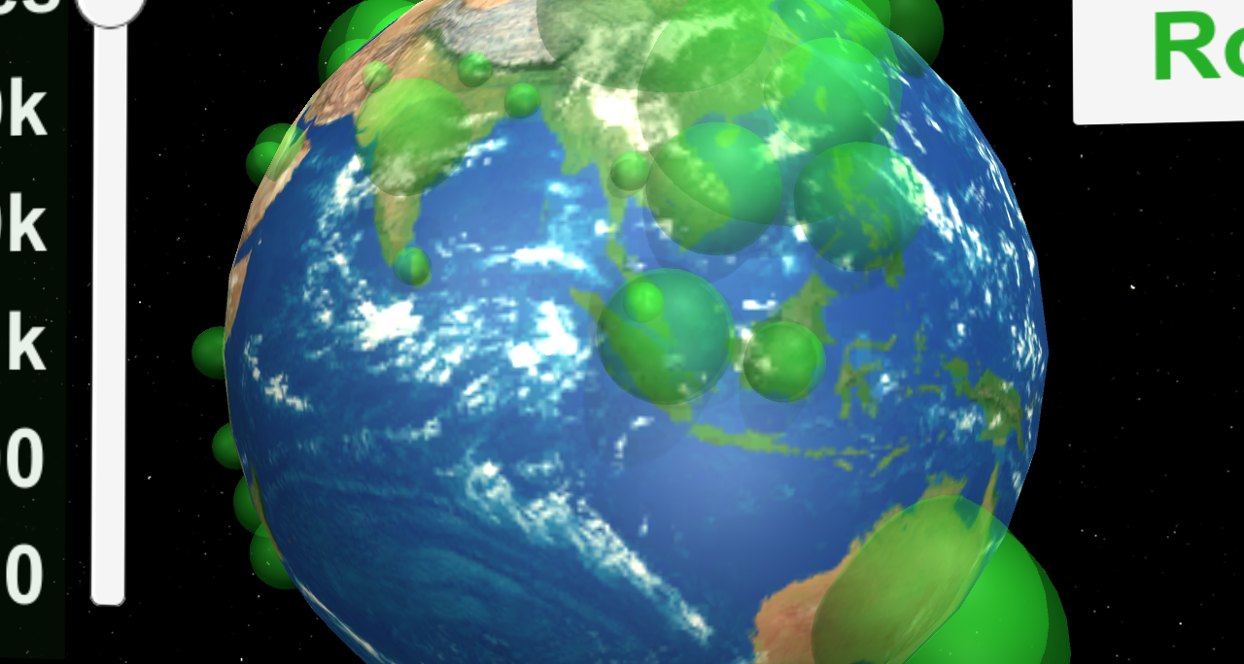

*Figure 3: Data closely viewed when zooming in (by clicking the satellites)*

Finally, as a learning tool, this prototype demonstrates the insights that may not be possible in a purely numerical or 2D experience. Being able to move closer or view the globe from different angles can provide unique insights. The VR experience can quickly show the impact the lockdown had on LEARN access from different parts of the world.

1. **Challenges and learnings**

Our team built on the Unity experience gained from our AR project, but still faced challenges. One of the main ones was how to take a country and work out how to translate that into accurate longitudinal and latitudinal data on a virtual globe. We then had to take the associated data for each country and display it dynamically at the right location. The time frame for completion was also a challenge, being considerably shorter than the previous assignment. We had to work efficiently, but were pleased in our ability to complete our work despite the time challenges.

A development step would be to include more information about each data point. For example, when you select a country it could show information about the number of users and the situation of that country under COVID-19. Another idea would be to break the data down to country regions. This would be especially useful within New Zealand, as we know this data is already being gathered.